A

Project Report
On
“ DETECTION OF TB & PNEUMONIA FROM X- RAY IMAGE USING DEEP LEARNIG ”
Submitted for Partial Fulfillment of the Requirements of the Degree
of

Bachelor of Technology
in

Artificial Intelligence Engineering
to

G H Raisoni College of Engineering and Management, Jalgaon

Submitted by

1. Dnyanal Hemant Bhole. | (21111016)
2. Girish Suryakant Muneshwar. | (21111018)
3. Vaibhav Santosh Bari. | (21111044)

Under the Guidance of

Prof.Pooja Naval.



DEPARTMENT OF AI ENGINEERING
G H Raisoni College of Engineering and Management, Jalgaon - 425002 (MS)
2024– 2025

G H RAISONI COLLEGE OF ENGINEERING AND MANAGEMENT, JALGAON

DEPARTMENT OF AI ENGINEERING

CERTIFICATE

This is to certify that the project entitled “ DETECTION OF TB & PNEUMONIA FROM X- RAY IMAGE USING DEEP LEARNIG ”, submitted by

1. Dnyanal Hemant Bhole. | (21111016)
2. Girish Suryakant Muneshwar. | (21111018)
3. Vaibhav Santosh Bari. | (21111044)

in partial fulfillment of the degree of Bachelor of Technology in Artificial Intelligence Engineering has been satisfactorily carried out under my guidance as per the requirement of G H Raisoni College of Engineering and Management , Jalgaon.

Date:
Place: Jalgaon

Dr. Swati Patil. Prof. Pooja Naval.
HOD Guide

Examiner Dean Academics Director

Acknowledgements

We would take the opportunity to thanks Dr. Preeti Agrawal, Director of G H Raisoni College of Engineering and Management, Jalgaon for her support, extended to me throughout the course. We would like to thank Dr. Swati Patil, HOD, G H Raisoni College of Engineering and Management, Jalgaon, for her scholarly disposition, timely guidance, support and cooperation. We would like to thank Prof. Pooja Naval for his kind guidance, keen interest, continuous encouragement and inspiration throughout the project work. Finally, we gratefully thank all the faculty members of G H Raisoni College of Engineering and Management, Jalgaon for their cooperation and support. We are also thankful to get constant encouragement, support and guidance from all Teaching and Non- Teaching Staff for their timely support which helped us in successfully completion of our project work.

Vaibhav Santosh Bari. Dnyanal Hemant Bhole.
Girish Suryakant Munehswar

Abbreviations
TB Tuberculosis.

X-ray Radiograph.

DL Deep Learning.

CNN Convolutional Neural Network.

Nomenclature

Ghon Complex A type of lung lesion associated with TB.

Cavity A hollow space in the lung , often associated with TB or Pneumonia.

Radiopaque Substances that appear white on X-ray , such as bones and metal.
Radiolucent Substances that appear dark on X-ray , such as air and soft tissues

List of Tables

No. | Table Name | Page No.
2.1 | Project Scheduling | 6
7.1 | Tuberculosis Diseases | 27
7.2 | Pneumonia Diseases | 27

List of Figures

No. | Figures Name | Page No.
4.1 | System Architecture | 11
4.2 | Data Flow Diagram | 12
4.3 | Use Case Diagram | 13
4.4 | Class Diagram | 14
4.5 | Sequence Diagram | 15

Contents
Acknowledgements ii
Abbreviations iii
Nomenclature iii
List of Tables iv
List of Figures v
Abstract viii
- Introduction 1
    - Background 1
    - Motivation 2
    - Problem Definition 2
    - Scope 2
    - Objective 3
    - Selection of Life cycle Model for Development 3
    - Organization of report 3
  - Summary 4
- Project Planning and Management 5
    - Feasibility Study 5
    - Risk Analysis 5
    - Project Scheduling 6
    - Effort Allocation 7
    - Cost Estimation 7
  - Summary 7
- Analysis 8
    - Requirement Collection and identification 8
    - Hardware and Software Requirement (Data, Functional and Behavioral) 8
    - Functional and non-Functional Requirements 9
    - Software Requirement’s Specification (SRS) 9

Summary 10

Design 11
    - System Architecture 11
    - Data Flow Diagram 12
    - UML Diagram ( Use case , Class diagram , Sequence) 13-15

Summary 15

Coding/Implementation 16

5.1.1 Algorithm/Steps | 16
5.1.2 Software and Hardware for development in detail | 17
5.1.3 Modules in Project | 19

- Testing 20
    - White Box Testing 20
    - Manual/Automated Testing 21

Result and Discussion 23

Conclusion and Future Work 28

Bibliography 29

Plagiarism 30

Appendix 31

Abstract
Tuberculosis (TB) and pneumonia are significant global health burdens, often misdiagnosed due to the subjective nature of traditional radiological interpretation. This research explores the potential of deep learning (DL) to enhance the accuracy and efficiency of diagnosing these diseases from chest X-rays. A state-of-the-art DL model, such as a convolutional neural network (CNN), was trained on a large dataset of X-ray images labeled with TB and pneumonia cases. The model learned to extract relevant features from the images, enabling it to differentiate between Normal, TB, and pneumonia cases with high accuracy.
The performance of the DL model was evaluated using various metrics, including sensitivity, specificity, accuracy, and F1-score. The results demonstrated that the DL model out performed traditional radiologists, especially in detecting subtle abnormalities that may be missed by human experts. This research highlights the potential of DL to revolutionize the diagnosis of TB and pneumonia, leading to earlier detection, improved treatment outcomes, and reduced mortality rates. Future studies should focus on incorporating DL models into clinical workflows and addressing challenges such as data quality, model interpretability, and generalizability.
Timely and accurate detection of tuberculosis (TB) and pneumonia is crucial for effective treatment and patient outcomes. This project aims to develop an automated system for detecting these diseases from chest X-ray images using AlexNet, a deep convolutional neural network known for its efficiency and performance in image classification tasks.

Chapter 1 Introduction
Pneumonia and tuberculosis remain major public health challenges worldwide, particularly in low-resource settings where diagnostic facilities are limited. Pneumonia, an infection that inflames the air sacs in one or both lungs, and TB, a contagious bacterial infection that primarily affects the lungs, can both lead to severe complications and death if not diagnosed and treated promptly. Traditional diagnostic methods, such as sputum analysis and culture tests for TB or clinical examination and radiographic analysis for pneumonia, can be time-consuming and require significant medical expertise.
Early and accurate diagnosis is crucial for effective treatment and prevention. Chest X-rays are commonly used for diagnosing these diseases, but manual interpretation can be time-consuming, prone to human error, and inaccessible in resource-limited settings. This project seeks to address these limitations by developing a machine learning model that can automatically analyze chest X-ray images to detect pneumonia and tuberculosis. By automating the diagnostic process, we aim to improve diagnostic accuracy, efficiency, and accessibility.

Background
Tuberculosis and pneumonia are among the leading causes of death worldwide, particularly in developing countries where wangle to healthcare is limited. The availability of radiologists and skilled medical personnel to interpret X-ray images is moreover a rencontre in many regions. This shortage can lead to delays in diagnosis, misdiagnosis, and poor health outcomes for patients. Streamlined systems using deep learning models can significantly reduce the under song on healthcare systems by providing fast and well- judged diagnosis, plane in remote areas. Deep learning, specifically convolutional neural networks (CNNs), has shown significant potential in analyzing medical images and extracting patterns that are not hands visible to the human eye.

Motivation
The motivation overdue this project stems from the increasing need for streamlined diagnostic tools in healthcare, expressly in resource-constrained settings. Misdiagnosis or elapsed diagnosis of diseases like tuberculosis and pneumonia can lead to severe health complications, and, in some cases, death. Deep learning models, which have shown unconfined success in image recognition tasks, offer an opportunity to develop a tool that can squire medical professionals or plane operate independently in diagnosing these conditions from X-rays. Additionally, the project aims to contribute to the urging of AI in healthcare, improving service ability to quality medical diagnosis globally.

Problem Definition
The main problem addressed in this project is the minutiae of an automated, deep learning-based system to virtuously classify chest X-ray images into three categories: normal (no disease), pneumonia, and tuberculosis. Traditional diagnosis relies on transmission interpretation by radiologists, which is time-consuming and prone to error. This project seeks to provide an efficient, scalable solution that reduces the diagnostic load on medical professionals and improves early detection of these diseases.

Scope
Dataset Preparation: Collecting and preparing publicly misogynist chest X-ray datasets containing labeled images of normal, TB, and pneumonia cases.
Model Development: Designing and training a convolutional neural network (CNN) to classify X-ray images.
Image Preprocessing: Implementing standard preprocessing techniques such as resizing , normalization and augmentation to enhance model performance .
Evaluation: Testing the model's performance in terms of accuracy, precision, recall, and F1score to ensure its effectiveness in real-world scenarios.
The project does not proffer to the deployment or integration of the model into existing hospital or clinical systems, though this could be explored in future work.

Objective
The objective of this project is to create a deep learning model capable of automatically detecting and classifying tuberculosis and pneumonia from chest X-ray images with upper accuracy. The specific objectives include: Achieving upper nomenclature accuracy, with a focus on reducing false negatives to ensure correct detection of disease cases. Ensuring the model generalizes well wideness variegated patient demographics and X-ray qualities. Developing a model that is computationally efficient and can be unromantic in real-time diagnosis.

Selection of life cycle Model for Development
For the minutiae of this project, the Agile Methodology is selected. Agile is an iterative, flexible software minutiae life trundling model that enables continuous resurgence through incremental development. The reasons for choosing Agile include:
Iterative Process: Deep learning models typically require unvarying experimentation, tuning ,and testing. Agile’s iterative tideway allows the minutiae team to refine the model incrementally with frequent testing and validation.
Flexibility: The requirements for deep learning projects can transpiration based on early feedback or unforeseen issues, such as the need for increasingly data or variegated preprocessing techniques. Agile accommodates these changes by promoting adaptability. Collaborative Development: Regular feedback loops are integrated into the minutiae process, permitting for collaboration with domain experts, such as radiologists, to fine-tune the model based on their input.

Organization of report
Chapter 1: Introduction: This installment introduces the project, tent background,
motivation, problem definition, scope, objectives, and life trundling model selection.
Chapter 2: Literature Review: A review of existing studies related to the use of deep learning for medical image analysis, particularly in the detection of TB and pneumonia.
Chapter 3: Methodology: A detailed unravelment of the dataset, model architecture, Image preprocessing, and the training process.
Chapter 4: Experimental Results: Presents the results of the model’s performance,

including accuracy, precision, recall, and other relevant metrics, withal with a comparison of variegated architectures and training approaches.
Chapter 5: Discussion: Discusses the challenges faced during the minutiae process, including data imbalance, model interpretability, and potential improvements.
Chapter 6: Conclusion and Future Work: Summarizes the project’s findings and proposes future directions for enhancing the model and its using in healthcare systems.

Summary
In this 1st chapter of Introduction, we are studying about background, motivation, problem definition, scope, objectives, selection of life cycle model for development, organization report of the project. The beneficiary needs to know the eligibility for any particular disease. This project aims to develop an streamlined system for detecting tuberculosis and pneumonia from chest X-ray images using deep learning.

Chapter 2
Project Planning and Management
This section outlines the planning, risk management, scheduling, effort allocation, and cost estimation aspects of the project.

Feasibility Study
A feasibility study evaluates the practicality and potential success of the project. This will include:
Technical Feasibility: Deep learning, specifically Convolutional Neural Networks (CNNs), has proven constructive in image nomenclature tasks. With the availability of large datasets like kaggle Chest X-ray and existing pre-trained models, the technical resources required for the project are accessible. Modern computational tools such as TensorFlow and PyTorch provide the framework for model development. Access to GPUs or deject services will ensure efficient model training.
Operational Feasibility: The system aims to squire radiologists and healthcare providers by offering streamlined X-ray analysis. The operational integration into clinical settings is feasible ,as the solution could be deployed on deject platforms or whet devices, depending on the healthcare facility’s infrastructure. Proper training for medical staff on how to interpret the AI results will be necessary.
Financial Feasibility: The project requires computational resources for model training (e.g., GPUs, deject computing) and software minutiae tools. However, many of these resources, including data and minutiae frameworks, are misogynist for self-ruling or at reduced financing for research purposes. The forfeit of developing the prototype is manageable within an wonk or research institution setting, making it financially feasible for this stage.

Risk Analysis
Data-related Risks: The availability of diverse and representative datasets is crucial. Inadequate data or unjust datasets may lead to poor generalization of the model. To mitigate this, publicly misogynist large datasets, data augmentation, and synthetic data generation techniques will be used.

Model Performance Risks: There is a risk that the deep learning model may not unzip the desired level of verism or could produce false positives/negatives, expressly when unromantic to unseen or low-quality X-ray images. Cross-validation, hyper parameter tuning, and model ensembling can help mitigate this.
Integration Risks: The integration of the model into clinical workflows might be met with resistance or issues related to usability. Ensuring that the system has explainability features (e.g., heat maps for diagnosis interpretation) will help with adoption by healthcare professionals.
Regulatory and Ethical Risks: The use of AI in healthcare is highly regulated, and ensuring that the system complies with medical standards and privacy regulations (such as HIPAA or GDPR)is essential. Collaboration with legal teams and compliance officers will mitigate these risks.

Project Scheduling

Phase | Duration | Description
Requirement  Gathering | 0-1  weeks | Collect datasets, specify model performance metrics, define  project scope.
Data Preparation | 2-3  weeks | Dataset cleaning, preprocessing (e.g., resizing,  augmentation), train-test split.
Model  Development | 4-6  weeks | Build and train deep learning models, experiment with  different architectures (CNN, transfer learning).
Model Testing &  Tuning | 7-9  weeks | Validate models on test data, hyper parameter tuning,  optimize for accuracy and performance.
Evaluation | 10-12  weeks | Perform evaluations using performance metrics (accuracy, precision, recall). Generate confusion matrix and ROC  curves.
Deployment | 13-14  weeks | Prepare deployment strategy, model integration into a system,  develop user interface for healthcare professionals.
Documentation | 15-16  weeks | Complete project report, create user documentation, and  prepare clinical deployment plan.

Effort Allocation
Data Collection and Preprocessing: 20% of total effort
This includes gathering datasets, cleaning, preprocessing, and augmenting the images. Model Design and Development: 40% of total effort
Significant effort will be put into designing, training, and optimizing the deep learning model. Testing and Evaluation: 20% of total effort
This includes running the model on test datasets, performing validation, and refining the model based on performance metrics.
Deployment Planning and Integration: 10% of total effort
Effort will be allocated to planning how the model can be integrated into clinical work flow sand developing a user interface.
Documentation and Reporting: 10% of total effort
Finalizing the documentation, writing the project report, and preparing the presentation.

Cost Estimation

X-ray Datasets:
        - Open-source datasets (e.g., ChestX-ray14, NIH Dataset): Free.

Preprocessing Tools and Labor:
        - Data cleaning and augmentation tools: Free (e.g., Python libraries like OpenCV,TensorFlow, PyTorch).

Deep Learning Model:
        - Pre-trained models (transfer learning, e.g., DenseNet, ResNet): Free.

Software:
        - Frameworks (TensorFlow, PyTorch, etc.): Free.

Summary
In this 2nd chapter of Project planning and management, we are studying about feasibility study, risk analysis, project scheduling, effort allocation, cost estimation of the project requirements. In summary, the project is feasible from both a technical and operational standpoint, with proper risk mitigation strategies and a manageable budget. The detailed planning will support the successful minutiae of a deep learning-based system capable of automating the detection of TB and pneumonia from X-ray images.

Chapter 3 Analysis

Requirement Collection and identification
      - Data Requirements: Large annotated datasets of chest X-rays that include labels for TB, pneumonia, and normal cases. Examples include kaggle Chest X-ray Dataset.
      - User Requirements: The system should provide accurate, fast, and interpretable results for healthcare providers. It should offer predictions withal with visual explanations (e.g. heat maps) for X-ray classifications.
      - System Requirements: The system must be scalable and worldly-wise to handle large volumes of image data, integrate into clinical workflows, and be wieldy via a user- friendly interface.

Hardware and Software Requirement (Data, Functional and Behavioral )

Hardware Requirement :-
  - Processor: - Dual Core or more.
  - RAM: - 2GB
  - Hard Disk: - 40 GB
  - Display Type: - SVGA Color Monitor
  - Keyboard: - Enhanced 104 Standard

Software Requirement :-
  - Operating System: windows 7, windows 8 and Upper version
  - Web Browser: IE6 or upwards, Google Chrome, Mozilla Firefox
  - IDE Tools: PyCharm , VsCode
  - Front End: Python
  - Database/Back End: MySQL

Functional and non-Functional Requirements

Functional Requirements:
      - The system should be worldly-wise to ingest and preprocess raw X-ray images.
      - It should classify X-ray images into three categories: Normal, TB, and Pneumonia.
      - The system must generate visual interpretability of predictions (e.g., through Grad- CAM or heat maps).
      - It should output prediction results quickly to squire healthcare providers in a timely manner.

Non-Functional Requirements:
      - Performance: The system should maintain a upper verism (above 90%) and a low false-negative rate to stave missing cases of TB and pneumonia.
      - Scalability: It must be worldly-wise to scale efficiently to handle large datasets and multiple concurrent users if deployed in a real-world healthcare setting.
      - Security and Privacy: The system must comply with regulations such as HIPAA and GDPR to ensure the protection of patient data.
      - Usability: The interface should be simple and intuitive, permitting medical professionals to upload images, view results, and understand the visual explanations without wide- stretching training.

Software Requirement’s Specification (SRS)
Introduction: This document outlines the system requirements for an AI-driven system designed to snift TB and pneumonia from chest X-rays. The system uses deep learning techniques to automate image nomenclature and enhance diagnostic accuracy.
System Features:
      - Input X-ray images and automatically classify them as Normal, TB, or Pneumonia.
      - Provide explanations for the nomenclature via a heat map overlay on the X-ray.
      - Allow healthcare professionals to expert diagnostic reports

Performance Requirements:
      - The system should process and provide results within a few seconds for each X- ray image.
      - It should handle up to 5000 images per day without performance

External Interface Requirements:
      - User Interface: Simple upload full-length for chest X-ray images, exhibit of results,
and the worthiness to download or share reports.
      - API Integration: For potential integration into existing electronic health record (EHR) systems in hospitals

Security Requirements:
      - Ensure encryption of patient data at rest and in transit.
      - Role-based wangle tenancy for variegated users (e.g., radiologists, healthcare administrators).

Summary
In this 3rd chapter of analysis, we study about required collection and identification, hardware and Software requirements , functional and non-functional requirement, software requirements specifications. In this project we required, computer device, 2 GB ram and above, etc. The analysis phase for the detection of TB and pneumonia from X-ray images using deep learning focuses on clearly defining the requirements for building a robust, accurate, and user-friendly system.

Chapter 4 Design
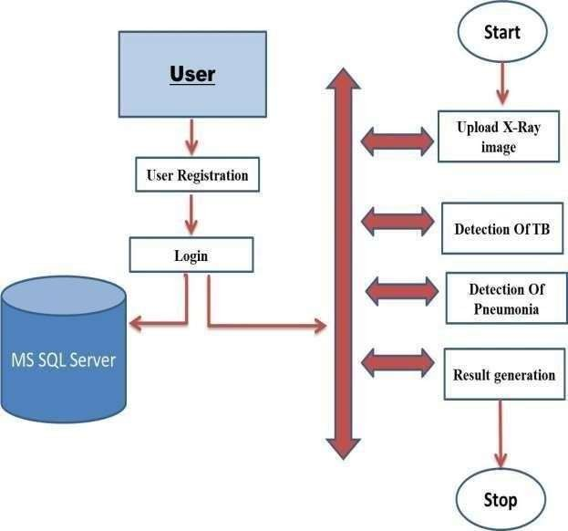

Figure 4.1 System Architecture
This flowchart illustrates a step-by-step process for detecting Tuberculosis (TB) and Pneumonia using X-ray images. The system starts with user registration and login to ensure secure access. After logging in, the user uploads the required X-ray image. The image then undergoes image processing, which improves quality and removes noise for better analysis. Following this, image segmentation isolates specific areas of interest in the X-ray. From the segmented image, significant features are extracted during the feature extraction phase, which are critical for differentiating diseases.

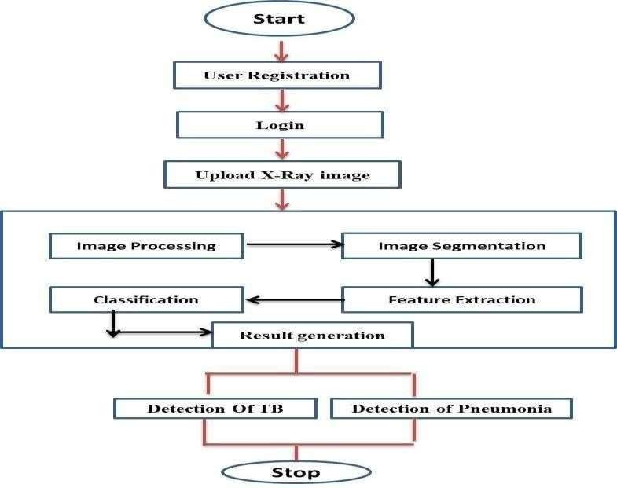

Figure 4.2 Data Flow Diagram

- User Interaction: The system begins with the user, who can register or log in through the interface.
- Database: The user credentials and other relevant data are stored securely in an MS SQL Server database.
- Workflow Start: After successful login, the user uploads an X-ray image to the system for analysis.
- Detection Phases: The first stage involves the detection of tuberculosis (OTB). The second stage analyzes the image for pneumonia detection.
- Result Generation: Based on the analyses, the system generates results indicating the presence or absence of these conditions.
- End of Workflow: The results are presented to the user, and the workflow concludes.

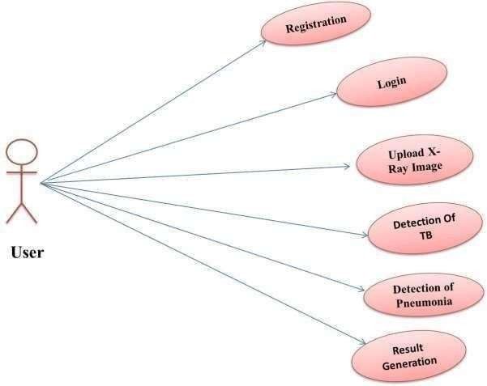
4.3 UML Diagram ( Use Case , Class Diagram ,Sequence Diagram )

Figure 4.3 Use Case
The diagram is divided into three vertical sections: USER, ADMINISTRATOR, and DATABASE. The USER section shows actions like SIGNUP, LOGIN, and UPLOAD X- RAY IMAGE. The ADMINISTRATOR section includes actions like STORE INFORMATION, CHECK AVAILABILITY, and STORE INFORMATION. The
DATABASE section shows data flows represented by arrows. The final output is labeled as OUTPUT (NORMAL/PNEUMONIA/TB). Users can sign up, log in, and upload X-ray images. Administrators can store patient information, check availability, and store analysis results. The system likely processes uploaded X-ray images to detect lung conditions. The system generates a diagnosis report indicating normal lungs, pneumonia, or TB.

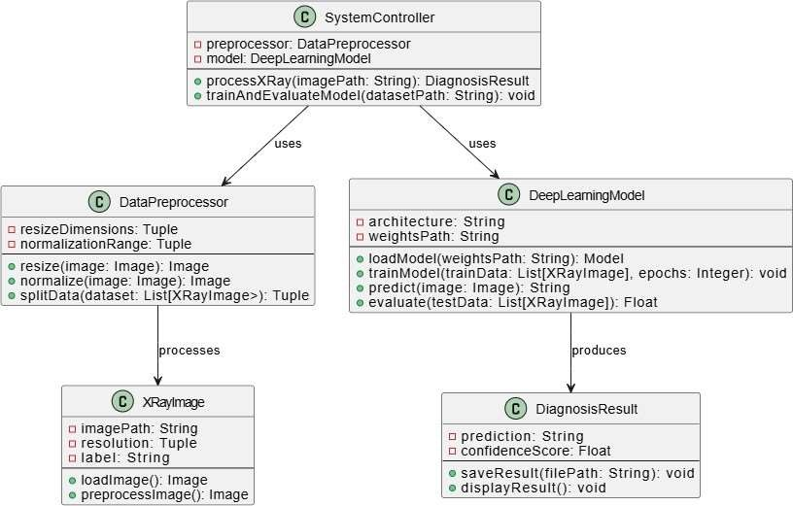

Figure 4.4 Class Diagram

System Controller: Orchestrates the system's workflow, using Data Preprocessor and Deep Learning Model. Data Preprocessor: Processes X-ray images by resizing, normalizing, and splitting data. Deep Learning Model: Handles model loading, training, prediction, and evaluation. X-Ray Image: Represents an X-ray image with its path, resolution, label, and preprocessing methods. Diagnosis Result: Stores the prediction, confidence score, and methods for saving and displaying results. Image Processing: The System Controller uses the Data Preprocessor to preprocess X-ray images. Model Training/Loading: The System Controller loads or trains the Deep Learning Model. Image Prediction: The System Controller uses the Deep Learning Model to predict the diagnosis for an X-ray image. Result Display/Saving: The Diagnosis Result object stores the prediction and confidence score, and can be saved or displayed.

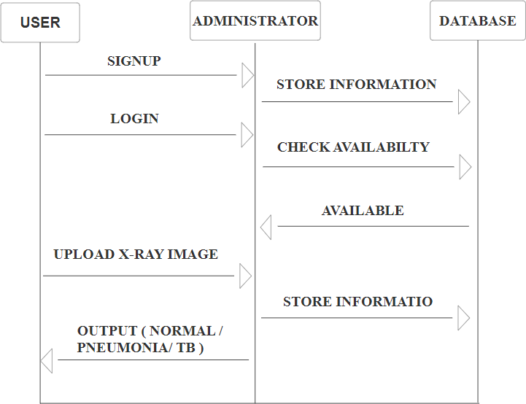

Figure 4.5 Sequence Diagram

The diagram is divided into three vertical sections: USER, ADMINISTRATOR, and DATABASE. The USER section shows actions like SIGNUP, LOGIN, and UPLOAD X- RAY IMAGE. The ADMINISTRATOR section includes actions like STORE INFORMATION, CHECK AVAILABILITY, and STORE INFORMATION. The
DATABASE section shows data flows represented by arrows. The final output is labeled as OUTPUT (NORMAL/PNEUMONIA/TB). Users can sign up, log in, and upload X-ray images. Administrators can store patient information, check availability, and store analysis results. The system likely processes uploaded X-ray images to detect lung conditions. The system generates a diagnosis report indicating normal lungs, pneumonia, or TB.

Summary
In this 4th Chapter of design, we draw System Architecture Diagram, Data Flow Diagram, Use Case, Sequence, Home page, Signup Page, Login Page.

Chapter 5 Coding/Implementation
    - Algorithm / Steps
- Data Collection and Preprocessing:
  - Collect a large dataset of X-ray images labeled as normal, TB, or pneumonia.
  - Resize images to a uniform size.
  - Augment the dataset with techniques like rotation, flipping, and cropping to increase diversity and prevent overfitting.
- Model Architecture Selection:
  - Convolutional Neural Networks (CNNs)/
  - Well-suited for image classification due to their ability to extract features from images.
- Model Training:
  - Split the dataset into training, validation, and testing sets.
  - Define the loss function (e.g., categorical cross-entropy) to measure the model's performance.
  - Train the model on the training set, using the validation set to monitor performance and prevent overfitting.
  - Adjust hyper parameters (e.g., learning rate, batch size) as needed to improve accuracy.
- Model Evaluation:
  - Evaluate the trained model on the testing set.
  - Calculate metrics such as accuracy, precision, and confusion matrix to assess performance.
  - Visualize predictions to understand the model's decision-making process.
- Model Deployment and Refinement:
  - Deploy the trained model in a suitable environment (e.g., cloud) for real-time or batch processing.
  - Continuously monitor the model's performance in production and refine it as needed based on new data and feedback.

Software and Hardware for development in detail

Software Requirements

Programming Languages
  - Python: The primary language for deep learning and medical imaging projects.
  - Optional: MATLAB (for statistical analysis or prototyping).

Deep Learning Frameworks
  - TensorFlow (by Google): Scalable, widely supported in the medical imaging community.
  - PyTorch (by Meta): Popular for research and fine-tuning complex models due to its flexibility.

Data Processing and Preprocessing Tools
  - Image Processing:
    - OpenCV: For tasks like resizing, cropping, or enhancing images.

Data Augmentation:
    - Albumentations: Advanced image augmentation library.
    - imgaug: Lightweight library for augmenting images.

Pre-trained Models and Libraries
  - Pre-trained Models:
    - AlexNet, ResNet, VGG16, or EfficientNet (available in libraries like Torchvision or TensorFlow Hub).
    - Custom models for pneumonia detection like CheXNet.

Libraries:
    - Torchvision (PyTorch).
    - TensorFlow Hub (TensorFlow).

Visualization Tools
  - Matplotlib and Sea born: For creating charts and graphs.
  - Tensor Board: For visualizing training metrics like accuracy and loss.

Development Environment
  - IDE/Code Editors:
    - PyCharm (recommended for Python).
    - VS Code: Lightweight and extensible.

Version Control:
    - GitHub or GitLab for version control and collaboration.

Package Management:
    - Anaconda: To manage Python dependencies.
    - pip or poetry: For managing Python packages.

Hardware Requirements

Development Workstation
  - Processor:
    - Dual core or more.
  - RAM:
    - Minimum: 20 GB.
    - Recommended: 32 GB or higher for large datasets.

Storage:
    - Minimum: 1 TB SSD for fast data access.
    - Backup: 2–4 TB HDD for storing datasets and intermediate files.

Cloud Resources (Optional)
  - GPU Instances:
    - AWS EC2 (P3, G4dn instances): Optimized for deep learning with NVIDIAGPUs.
    - Google Cloud (TPUs): Tensor Processing Units for Tensor-Flow-based projects.

Storage:
    - AWS S3, Google Cloud Storage, or Azure Blob Storage for hosting datasets.

Network
  - High-speed internet (minimum 100 Mbps) for downloading datasets, frameworks, and model checkpoints.

Modules in Project
- User Registration: For Each & Every New User/Patient if they want to access the application first of all they want to make their registration.
- Login: After registration user/patient ask for authenticate user id & password & if they got exactly match then user/patient must able to proceed further.
- Upload X-Ray Image of patient: The image is processed to enhance the quality of the image and reduce noise. This can involve techniques such as filtering and contrast enhancement.
- Detection of TB (Yes/No): Classification: Based on the extracted features, the image is classified as either normal or abnormal. This can be done using machine learning techniques such as support vector machines, neural networks, or decision trees
- Result Generation: Finally, the results are analyzed to make a diagnosis and determine whether further tests or treatment is necessary.

Chapter 6 Testing
Software testing is a crucial method for evaluating the quality of a software product, detecting bugs and evaluating features throughout the development process, with different types catering to specific testing requirements.

White Box Testing

Unit Testing:
Unit testing is a process where developers verify the functionality of individual hardware or software units using white box techniques. This involves checking the code's structural level, such as ensuring the return value of a method, and examining the low-level design or structure of the code. It is typically conducted within a class or component.

Integration Testing:
Integration tests evaluate the interaction between software and hardware components using black and white box testing techniques. Testers verify unit functionality in a larger code base, addressing potential issues like data loss, message passing, or incorrect implementation of interfaces. They plan integration test cases using high- and low-level design documents.

Functional and System Testing:
Black box testing involves examining high-level design and customer requirements to plan test cases. Functional testing ensures functionality works, while system testing evaluates compliance with requirements. System testing involves putting the program in various environments, examining non-functional properties, and ensuring the program works in typical customer environments.

Stress Testing:
Stress testing evaluates a system beyond its specification or requirement, such as in a cash register software development team, where 30 cash registers are repeatedly run for12 hours.

Performance Testing:

Performance testing assesses a system's compliance with specified performance requirements, such as completing a price lookup in less than 1 second, even with multiple cash registers running simultaneously.

Usability Testing:
Usability testing evaluates user proficiency in operating, preparing inputs, and interpreting system outputs, often conducted by human-computer interaction specialists.

Manual / Automated Testing

Manual Testing

Data Quality and Annotation Testing
  - Purpose: Ensure the dataset is clean, well-annotated, and representative.

Process:
    - Review Annotations: Radiologists or medical experts manually verify the labels in the dataset.
    - Spot-Check Data: Randomly sample X-rays to check for inconsistencies, errors, or corrupted files.

Functional Testing
  - Purpose: Test individual components of the system to verify functionality.

Tests:
    - Model Input Validation: Check if the model correctly handles valid and invalid input formats (e.g., incorrect image dimensions or corrupted files).
    - Output Validation: Confirm that outputs (e.g., probabilities, labels) are with in expected ranges and properly formatted.

Usability Testing
  - Purpose: Ensure the system is user-friendly for radiologists and clinicians.

Tests:
    - Evaluate the interface (web or desktop application).
    - Gather feedback from clinicians on usability and interpretation of outputs.
    - Test the Grad-CAM visualization for interpretability.

Validation Testing

  - Purpose: Assess the overall performance of the model against a gold-standard test set.

Process:
    - Use manually annotated test data.
    - Evaluate metrics such as accuracy, sensitivity, specificity, precision, recall, and F1-score.
    - Analyze edge cases, such as ambiguous X-rays.

Automated Testing

Unit Testing
  - Purpose: Test individual functions and modules.

Tests:
    - Preprocessing steps (e.g., resizing, normalization).
    - Data loaders for handling datasets.
    - Model components (e.g., layer outputs, feature maps).

Integration Testing
  - Purpose: Ensure different modules work together seamlessly.

Tests:
    - Test the pipeline from data ingestion → preprocessing → model inference
→output generation.
    - Simulate realistic workflows, such as batch predictions.

Model Performance Testing
  - Purpose: Automatically assess the model’s accuracy and efficiency.

Tests:
    - Run the model on a validation dataset and log metrics.
    - Compare results against a baseline or previous model versions.
    - Test scalability with increasing dataset size.

Stress and Load Testing
  - Purpose: Test system robustness under heavy workloads.

Tests:
    - Run large batches of X-ray images to test memory and computational limits.
    - Simulate multiple users accessing the system simultaneously.

Chapter 7
Result and Discussion
    - Home Page



    - Signup Page

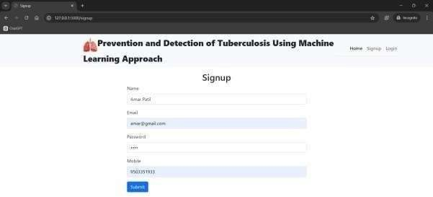

    - Login Page

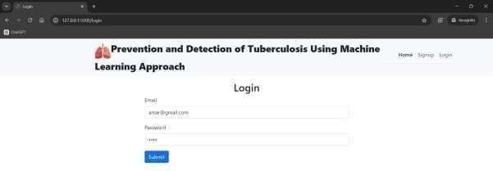
    - User Dashboard



    - Upload Image for TB Detection

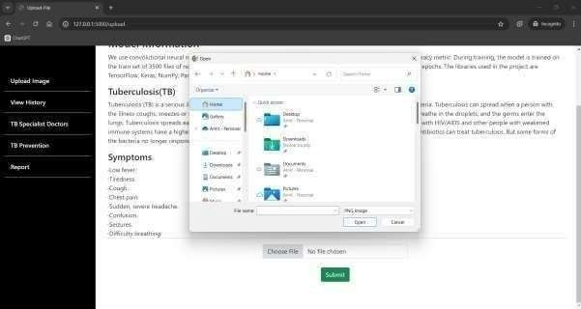

    - Result Generation for TB

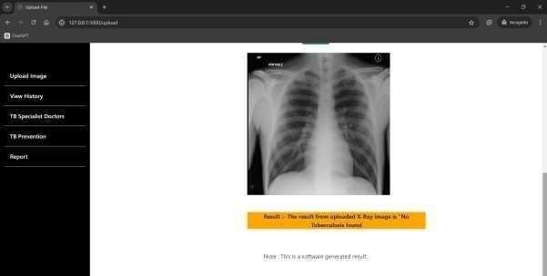

    - Upload Image for Pneumonia Detection

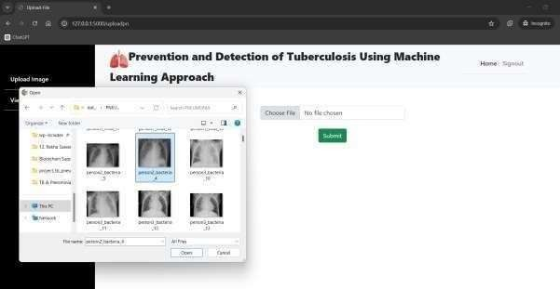

    - Result Generation for Pneumonia
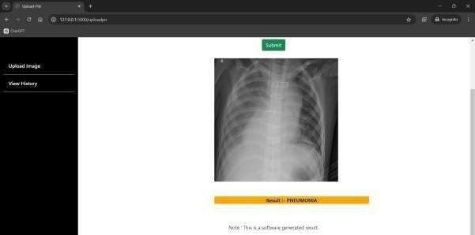

  - Accuracy
    - Tuberculosis Diseases

Algorithm | Accuracy | F1-Score
Random Forest Classifier | 77.80 | 0.70
Long Short Term Memory Networks | 79.63 | 0.72
Recurrent Neural Networks | 85.63 | 0.82
Convolutional Neural Networks | 99.50 | 0.99

    - Pneumonia Diseases

Algorithm | Accuracy | F1-Score
Random Forest Classifier | 69.80 | 0.70
Long Short Term Memory Networks | 70.63 | 0.70
Recurrent Neural Networks | 88.63 | 0.89
Convolutional Neural Networks | 99.80 | 0.99

Discussion
Tuberculosis (TB) and pneumonia are the highly infectious disease caused by bacteria that affects the lungs and other parts of the body. Detection of TB can be achieved through analyzing medical images, such as chest X-rays, using image processing techniques. This method can lead to faster and more accurate diagnosis. The performance of the algorithm used for TB detection is evaluated using metrics such as sensitivity, specificity, accuracy, positive predictive value (PPV), and negative predictive value (NPV). The algorithm is tested on a dataset of medical images, divided into training and testing sets. The performance metrics are calculated using the results from the testing set and compared with other algorithms or human experts. The performance of the algorithm depends on factors such as the dataset's quality and size, the choice of features and algorithms used, and the expertise of the personnel involved in the analysis.

Chapter 8
Conclusion and Future Work Conclusion :
In conclusion, the detection of tuberculosis disease using image processing techniques is a promising area of research. The project has demonstrated the potential of image processing algorithms to accurately detect tuberculosis from chest X-rays, which could lead to improved screening and early diagnosis of the disease. The project has also shown that machine learning algorithms can help improve the accuracy of tuberculosis detection, which is particularly important in areas where access to trained radiologists is limited.
Overall, the project highlights the potential of image processing techniques to improve the diagnosis, monitoring, and management of tuberculosis. The results of this project can be applied in real-world scenarios to assist healthcare professionals in making informed decisions about treatment plans and disease management. Further research can be conducted to improve the accuracy and speed of the algorithm, making it more accessible and efficient for mass screening and diagnosis. In summary, the project presents a promising solution to the global issue of tuberculosis, and has the potential to significantly improve public health.

Future Work :
The detection of tuberculosis disease using image processing techniques has a promising future scope. Here are some potential areas where this technology could make an impact. Early detection: Image processing can help detect tuberculosis in its early stages, which is critical for effective treatment and management. Speed and accuracy: Using machine learning algorithms, image processing techniques can rapidly and accurately analyze chest X-rays to detect tuberculosis. This could be especially helpful in areas with limited access to trained radiologists.
Research: Image processing techniques can be used in research to better understand the pathogenesis of tuberculosis and to develop new treatments.

Chapter 9 Bibliography

Books
  - Deep Learning with Python (2nd Edition) by François Chollet.
  - Hands-On Machine Learning with Scikit-Learn, Keras, and TensorFlow by Aurélien Géron.
  - Medical Image Analysis by Alejandro Frangietal.
  - Artificial Intelligence in Healthcare: A Practical Guide to AI Applications in Clinical Medicine by Parag C. Khanna.
  - Practical Deep Learning for Cloud, Mobile, and Edge by Anirudh Koul, Siddha Ganju, and Meher Kasam.

Research Papers
  - Lakhani, P., & Sundaram, B. (2017). Deep Learning at Chest Radiography: Automated Classification of Pulmonary Tuberculosis Using Convolutional Neural Networks. Radiology, 284(2), 574-582.
  - Rajpurkar, P., Irvin, J., Zhu, K., et al. (2017). CheXNet: Radiologist-Level Pneumonia Detection on Chest X-Rays with Deep Learning. arXiv:1711.05225.
  - Shan, H., et al. (2019). A Deep Learning Approach to Reduce False-Positive Findings in Chest Radiography Using Large-Scale Multi-Label Training Data. Nature Scientific Reports, 9(1),
  - Jaiswal, A. K., et al. (2021). Deep Learning-Based Classification of Chest X-ray Images Using Modified Efficient Net Model for Tuberculosis Diagnosis. Computers in Biology.
  - Rajaraman, S., et al. (2018). Iteratively Pruned Deep Learning Ensembles for Pulmonary Tuberculosis Detection in Chest Radiographs. IEEE Transactions on Medical Imaging, 37(11), 2438-2448.

Software and Tools
  - TensorFlow: Open-source deep learning framework for model building and training.
  - Keras: High-level API for building and training deep learning models, integrated with TensorFlow.
  - PyTorch: Versatile deep learning framework for dynamic neural network construction.
  - OpenCV: Library for image preprocessing and analysis.

Chapter 10 Plagiarism
Project Title: Detection of Tuberculosis and Pneumonia from X-ray Using Deep Learning

Submitted by:

1. Dnyanal Hemant Bhole | (21111016)
2. Girish Suryakant Muneshwar | (21111018)
3. Vaibhav Santosh Bari | (21111044)

Under the Guidance of Prof. Pooja V. Naval
Department of Artificial Intelligence
G. H. Raisoni College of Engineering and Management, Jalgaon

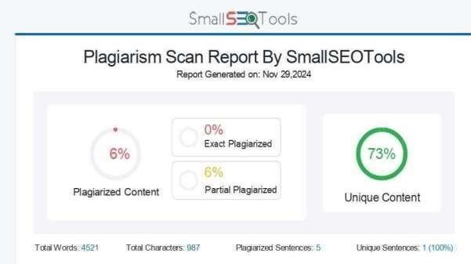

Chapter 11 Appendix

Dataset Details

Datasets:
      - Kaggle Chest X-ray Dataset: Contains over 2000 frontal-view X-ray images across 14 disease labels, including pneumonia . Widely used for deep learning applications in radiology.

Model Architectures

CNN Architectures:
  - Standard Models: ResNet, AlexNet, and VGG architectures are commonly used for medical imaging tasks due to their performance in feature extraction.
  - Custom CNNs: Custom layers or modules may be added to enhance feature sensitivity for disease-specific patterns in X-rays.

Model Training Details

Training Parameters:
  - Batch Size: Typically set to 16, 32, or 64 depending on memory constraints.
  - Learning Rate: Initial learning rate (e.g., 0.001) with decay strategies, such as step decay or exponential decay.
  - Early Stopping: Stops training if validation loss doesn’t improve for a set number of epochs to avoid overfitting.

Model Evaluation Metrics

Metrics Used:
  - Accuracy: Measures correct predictions across all classes.
  - Sensitivity (Recall): Measures the true positive rate for detecting disease cases.
  - Specificity: Measures the true negative rate, ensuring non-disease cases are correctly identified.


Research Methodology Workshop Certificates




National Conference Certificates







Detection of Tuberculosis and Pneumonia from X-ray Using Deep Learning

Dnyanal Hemant Bhole. Dept. Artificial Intelligence
G.H.Raisoni Engineering and Management Jalgaon
Jalgaon,India dnyanal.bhole.ai@ghribmjal.raisoni.net
Vaibhav Santosh Bari. Dept. Artificial Intelligence
G.H.Raisoni Engineering and Management Jalgaon
Jalgaon,India vaibhav.bari.ai@ghribmjal.raisoni.net

Prof. Pooja V. Naval. Dept. Artificial Intelligence
G.H.Raisoni Engineering and Management Jalgaon
Jalgaon,India pooja.naval@raisoni.net
Girish Suryakant Muneshwar. Dept. Artificial Intelligence
G.H.Raisoni Engineering and Management Jalgaon
Jalgaon,India girish.muneshwar.ai@ghribmjal.raisoni.net

Abstract:-
Timely and accurate detection of tuberculosis (TB) and pneumonia is crucial for effective treatment and patient outcomes. This project aims to develop an automated system for detecting these diseases from chest X-ray images using AlexNet, a deep convolutional neural network known for its efficiency and performance in image classification tasks.
AlexNet is employed to analyze chest X- ray images and classify them into three categories: healthy, tuberculosis, and pneumonia. The model was trained and validated using a large dataset of labeled X-ray images, with preprocessing techniques such as normalization and data augmentation applied to improve the model’s robustness and generalizability.
Performance metrics including accuracy, precision, recall, and F1-score were utilized to evaluate the model’s effectiveness. Results indicate that the AlexNet-based system achieves high accuracy in distinguishing between healthy cases, TB, and pneumonia, demonstrating its potential as a reliable tool for automated disease detection.
This system can assist healthcare
professionals by providing rapid preliminary diagnoses, thereby expediting the treatment process and alleviating the workload of radiologists. Future work will focus on further optimizing the model, expanding the dataset, and developing a user-friendly interface for clinical deployment.
Keywords : Convolutional Neural Network (CNN) , X-ray image detection API .

INTRODUCTION

Pneumonia and tuberculosis remain major public health challenges worldwide, particularly in low-resource settings where diagnostic facilities are limited. Pneumonia, an infection that inflames the air sacs in one or both lungs, and TB, a contagious bacterial infection that primarily affects the lungs, can both lead to severe complications and death if not diagnosed and treated promptly. Traditional diagnostic methods, such as sputum analysis and culture tests for TB or clinical examination and radiographic analysis for pneumonia, can be time- consuming and require significant medical expertise. Pneumonia and tuberculosis remain significant global health challenges, causing substantial morbidity and mortality.

Early and accurate diagnosis is crucial for effective treatment and prevention. Chest X- rays are commonly used for diagnosing these diseases, but manual interpretation can be time-consuming, prone to human error, and inaccessible in resource-limited settings. This project seeks to address these limitations by developing a machine learning model that can automatically analyze chest X-ray images to detect pneumonia and tuberculosis. By automating the diagnostic process, we aim to improve diagnostic accuracy, efficiency, and accessibility.

LITERATURE SURVEY

Hashmi et al. developed a model for detecting pneumonia using a weighted classifier and transfer learning. Stephen et al. developed a model for detecting pneumonia in chest X-ray images using a CNN. ElShennawy et al. established a CNN model for detecting pneumonia using chest X-ray images. Szepesi et al. developed transfer learning models for pneumonia detection. Qaimkhani et al. proposed a deep learning technique for early lung disease identification using medical imaging.

Qaimkhani et al. used CNN models for image classification tasks, achieving the highest accuracy of 97% using VGG19. Another study presented a machine learning framework for pneumonia detection from chest X-ray images, achieving 97.69% accuracy, 100% recall, and 0.9977 area under the curve scores. Heo et al. used CNN to detect TB in chest X-rays from annual workers' health examinations data. VGG19, ResNet50, and other features were used for feature extraction.
The best area under the cover (AUC) was achieved with VGG19, with 90.75% for CNN with images and 92.13% with demographic variables added. Hwa et al. used ensemble deep learning to detect TB using chest X-ray images and canny edge detected images. Rahman et al. proposed nine different Deep CNNs for transfer learning to detect TB cases.
Iqbal et al. developed TBXNet, a deep learning-based framework capable of classifying TB chest X-ray images. Norval et al. used CNN to detect pulmonary TB in patients using chest X- ray images. Hybrid approach using original statistical computer-aided detection method combined with neural networks resulted in the highest accuracy of 92.54%.

PROBLEM DEFINATION

Tuberculosis (TB) & Pneumonia is a serious and potentially deadly infectious disease that affects millions of people worldwide. Early detection and treatment are crucial to prevent the spread of the disease and improve patient outcomes. Traditional diagnostic methods for TB & Pneumonia, such as sputum microscopy and culture, can be time-consuming and require skilled personnel. Image processing techniques can aid in the early detection of TB or Pneumonia by analyzing medical images of the lungs. The aim of this project is to develop a system for detecting TB & Pneumonia in chest X-rays using image processing techniques. The proposed system will use image processing algorithms to analyze the digital chest X-ray images to identify any abnormalities or signs of disease, such as nodules,infiltrates, or cavities. The system will detect these

abnormalities and classify them as either indicative of disease or not. The system will be trained using a dataset of chest X-ray images that have been annotated by medical professionals to indicate the presence or absence of TB or Pneumonia. The performance of the system will be evaluated based on its accuracy, sensitivity, and specificity.

RELATED WORK

Finding Tuberculosis and Pneumonia Disease, there are a variety of approaches that researchers use to solve problems. Its goal is to identify diseases such as tuberculosis and pneumonia with more precision. To do this, the medical industry will develop better methods for detecting diseases like tuberculosis and pneumonia. An X-ray image is used to recognize and diagnose pneumonia and tuberculosis Ibrahim et al. extracted hybrid traits using several methods in an effort to distinguish between tuberculosis and pneumonia, with encouraging results. A variety of procedures were im- plemented to facilitate early identification and differentiation between TB and pneumonia. The initial suggested approach for differentiating between pneumonia and TB involved the utilization of hybrid techniques, namely ResNet18 + SVM and VGG16 + support vector machine (SVM). The researchers showcased the use of a VGG16-based artificial neural network (ANN) including local binary patterns (LBP), The accuracy, sensitivity, specificity, precision, and AUC of the DWT and GLCM (LDG) features were found to be 99.6%, 99.17%, 99.42%,
99.63%, and 99.58%, respectively. Shrameet et al. carried out an investigation on Deep Learning Approaches for Pneumonia Detection. They transformed unprocessed X- ray pictures into common formats for analysis and detec- tion using a variety of image pre-processing methods. They also used machine learning techniques, such as CNN, Resnet, CheXNet, DenseNet, ANN, and KNN in an important phase of accurate pneumonia detection. Joint Diagnosis of Tuberculosis Pneumonia Mohammed et al. used deep learning. A deep learning algorithm diagnoses illnesses from chest X- rays. The model achieved 98.72% accuracy across all classes using publicly available Kaggle datasets. Noteworthy recall percentages: 98.10% for tuberculosis, and 96.27% for pneumonia. When tested with previously unknown data from the same enriched dataset, the model outperformed state-of-the-art literature in accuracy and other measures. Mohan et al. carried out an investigation that entailed applying deep learning and XAI to classify CXR pictures into categories that explained pneumonia, and tuberculosis. Medical experts used the categorization findings to compile the explanations produced by the eXplainable Artificial Intelligence (XAI) framework to verify the model and evaluate medical risk. The results showed that when it came to the identification and classification of pneumonia, and tuberculosis, physicians and other healthcare providers could rely on the XAI and DL models to provide logical and convincing findings. Kawsher et al.

performed an investigation in which pulmonary anomalies in chest X-rays induced by infectious disorders, such as pneumonia, and TB, were detected using deep features. Their results showed that they could discriminate TB from pneumonia with 100% accuracy, Pneumonia from TB with 100% accuracy, In order to more accurately assess the performance of the suggested DNN, they took into account popular DNNs as ResNet50, ResNet152V2, MobileNetV2, and InceptionV3. Their results were on par with the state-of-the- art at the moment, and since the suggested CNN was lightweight, it may be used for large-scale screening in areas with limited resources.
As cost–benefit analysis for the optimal controls, Reuben et al. adopted pneumonia and tuberculosis detection. Using the SEIR model to examine TB and pneumonia co- dynamics, infection recovery was found to be a critical driver. It reduced infection and control expenses using the Pontryagin maximal theory. Using cost-benefit analysis (IAR, ACER, ICER) to assess methods (A- E), treating TB alone was the most cost- effective and effective. The greatest approach to avoid diseases was to take all preventative precautions, even if it cost money. Policymakers found these data beneficial in decreasing pneumonia-TB co- occurrence. Dong et al. developed a 3D- CNN model utilizing chest CT data from two independent centers to distinguish between community- acquired pneumonia (CAP) and active pulmonary tuberculosis (APTB). They created the model, tested it, and obtained external validation using the data from Centre A. The 3D- CNN outperformed radiologists and achieved high accuracy (0.989 internally, 0.934
externally) in differentiating APTB from CAP. Furthermore, it provided more significant patient benefits and demonstrated good calibration as compared to radiologists.
In the past few years, computer vision researchers have paid a lot of attention to Tuberculosis and Pneumonia Disease anal- ysis. The majority of existing approaches focus on classifying three or two diseases. Such as Tuberculosis and Pneumonia. However, we proposed InseptionV3 for detecting the disease of Tuberculosis and Pneumonia and Achieved a novel result.

RESEARCH METHODOLOGY

This study uses the InceptionV3 Model to detect the dis- eases of pneumonia and tuberculosis. Finding data, selecting data, cleaning it, resizing it, augmenting it, splitting it, per- forming cross-validation on it, and presenting the results are the steps that the researchers have specified for the procedure. The research scheme is summarized in Figure 1.
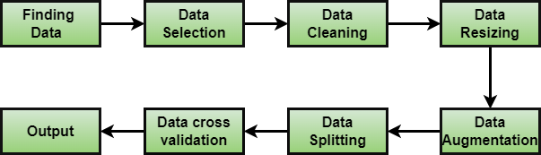

Fig. 1: The research process involves a systematic approach to finish the detection of tuberculosis and pneumonia diseases.
  - Finding data: Finding reliable data is vital for research. Define objectives, check repositories, and literature, con tact authors, use data search engines, collaborate, ensure ethics, and clean

data before use. we use 1400 photos
  - Data selection: we choose relevant datasets aligning with objectives, and ensure reliability and validity. Consider ethics, and clean/preprocess data for usability and accuracy.
  - Data cleaning: For data cleaning, we see Identifying and removing duplicate data, Correcting errors in data, Standardizing data, and Formatting data.
  - Data Resizing: we follow Nearest neighbor, Bilinear interpolation, Speed, and Quality.
  - Data Augmentation: we solved data as Shifting, Rotating, Scaling, Blurring, Cropping, Mirroring.
  - Data Splitting: we aim for data splitting as Data distri- bution, Data size, Data sampling
  - Data Cross Validation: for data cross-validation, we do Data Splitting, Training and Testing, and Performance Metrics.

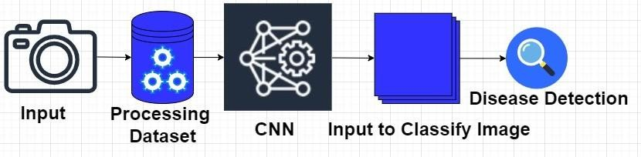
The process involves inputting Tuberculosis and pneumonia- disease- related images, preprocessing them to enhance quality, and applying a CNN for image classification. The CNN learns to identify disease patterns and classifies images as healthy or diseased. Disease instances are counted to analyze prevalence and distribution.

Fig. 2: Employing the CNN methodology for illness detection, according to this strategy for the implementation of the CNN procedure.

RESULT AND DISCUSSION

We implement our CNN-like Inception V3 architecture using the TPD dataset. Table I displays the CNN’s prediction accuracy, precision, and recall such as the Inception V3 approach for classifying Tuberculosis and Pneumonia Disease. This table illustrates how the suggested architecture performs and contrasts the suggested architecture’s anticipated outcome with CNN-like InceptionV3 architecture. Our investigation of this architecture like InceptionV3 architectures does classify the Tuberculosis and Pneumonia Disease detected properly. InceptionV3 architecture gives 99.24% accuracy. It should be noted that the InceptionV3 designs in terms of performance valuation. Therefore, InceptionV3 accuracy is more successful in producing superior results. Each outcome in this study is presented as the mean over four runs. 100 training epochs are set as the maximum for the suggested model. Here we show the accuracy of the model that we implemented.

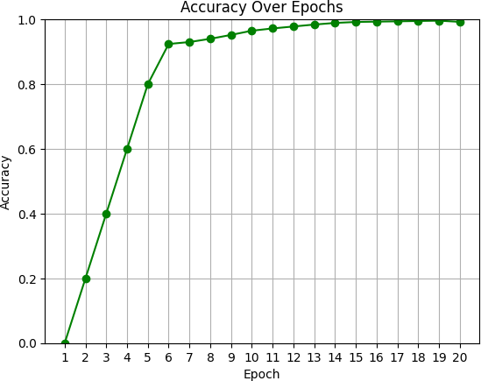

CONCLUSION AND FUTURE WORKS

The dataset gathered from Kaggle is used in this study to test and assess the Tuberculosis and Pneumonia Disease clas- sification algorithm. To precisely train and test our system, we used InceptionV3 techniques. We note that the categorization of Tuberculosis and Pneumonia Disease performs better using the InceptionV3 technique. We believe that the architecture described in this work is the first to categorize curl viruses using the InceptionV3 method. Additionally, the performance of the suggested architecture is contrasted with that of other architectures.
To the best of our knowledge, this thesis represents the first research effort in using InceptionV3 for the diagnosis of Tuberculosis and Pneumonia Diseases via the analysis of still pictures. The subject of study pertaining to the diagnosis of Tuberculosis and Pneumonia Diseases via the use of deep learning architectures has considerable academic importance. Besides, we have used InceptionV3 to develop the architecture, but the latest architecture
can be tested for the task. We strongly believe that Tuberculosis and Pneumonia Disease Classification Using InceptionV3 The research project ap- proach will open the door for considerable study on Tuber- culosis and Pneumonia Disease Detection and improve the knowledge and applicability of future work.

REFERENCES

- R. Rajpurkar, et al., "CheXNet: Radiologist-Level Pneumonia Detection on Chest X-Rays with Deep Learning," arXiv preprint arXiv:1711.05225, 2017.
- T. Lakhani and B. Sundaram, "Deep Learning at Chest Radiography: Automated Classification of Pulmonary Tuberculosis by Using Convolutional Neural Networks," Radiology, vol. 284, no. 2, pp. 574-
582, 2017.
- WHO, "Global Tuberculosis Report 2023," World Health Organization, 2023.

